**Note: Azure CLI, Terraform, Visual Studio Code need to be installed in your system.**

**Create a Bashscipt to provision 5 Resource groups using Azure CLI providing Count and Region during the execution of scripts.**

* Open the Azure Portal and navigate to the Azure Cloud Shell.
* Create a directory using **mkdir <directoryname>** and change directory using **cd <directory name>**
  + **Example: mkdir task2**
  + **Example: cd task2**
* Use **vi** command to create the file (use .sh extension) ,insert (use key ‘i’) and save the script
  + **vi create_resource_groups.sh**
* Use the below command to make the script executable. This is necessary before you can run the scripts directly from the command line.
  + **chmod +x create_resource_groups.sh**
* To run the script first navigate to the directory then **use ./< .sh file name> <number of resource groups> <location>**
  + **./create_resource_groups.sh 5 eastus**
  + 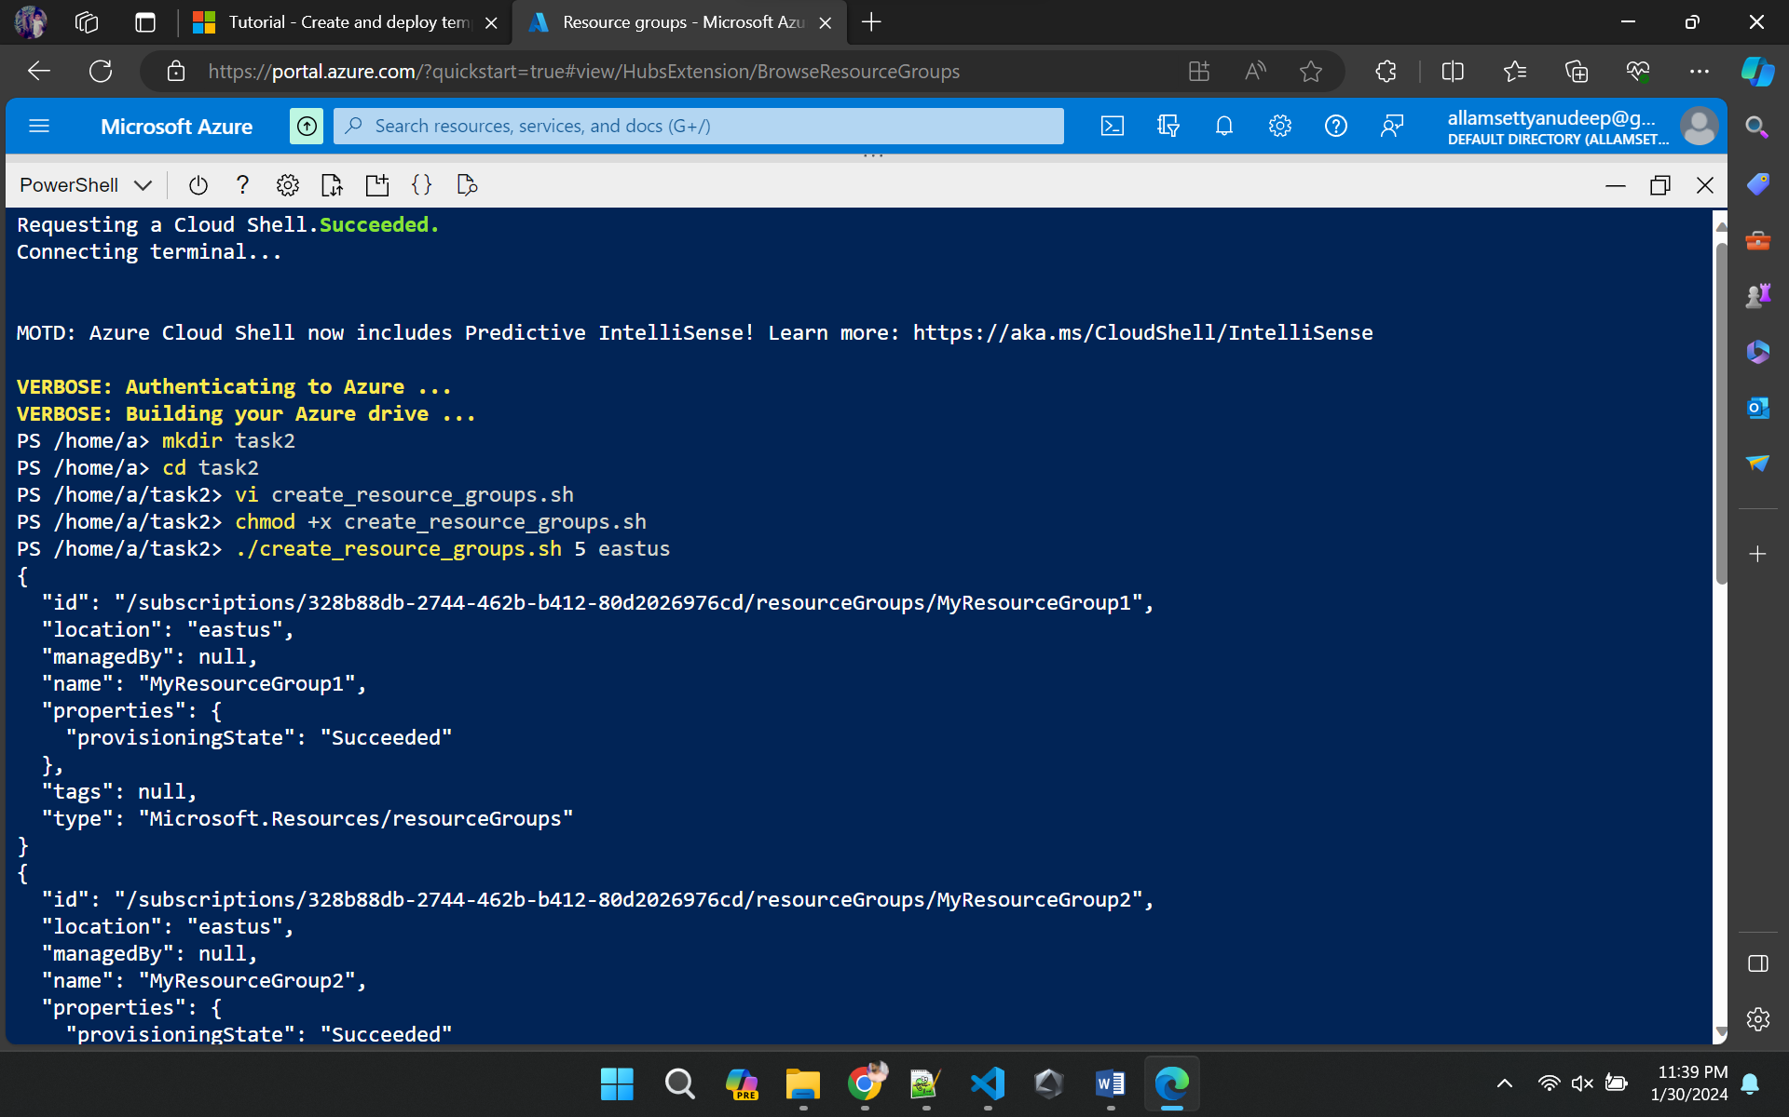

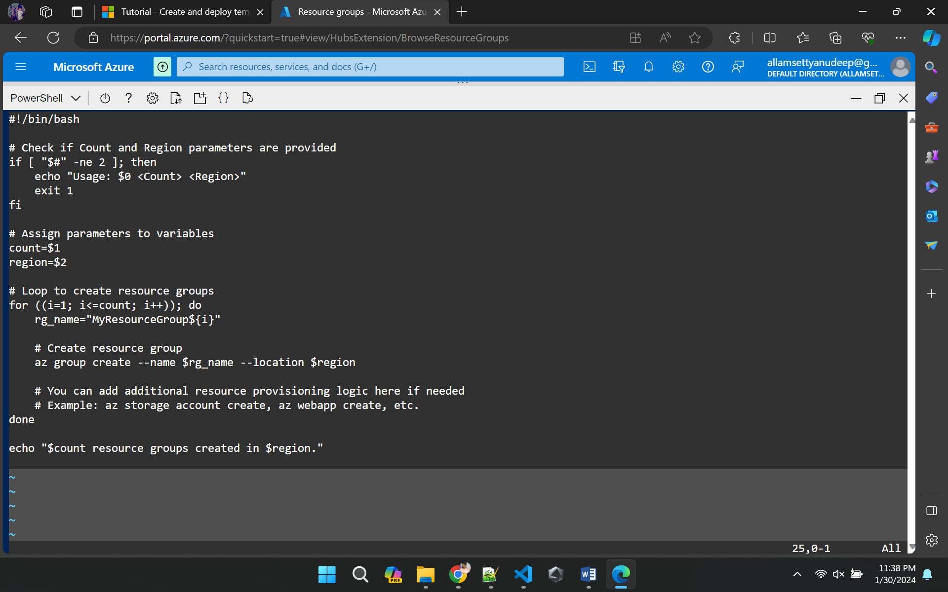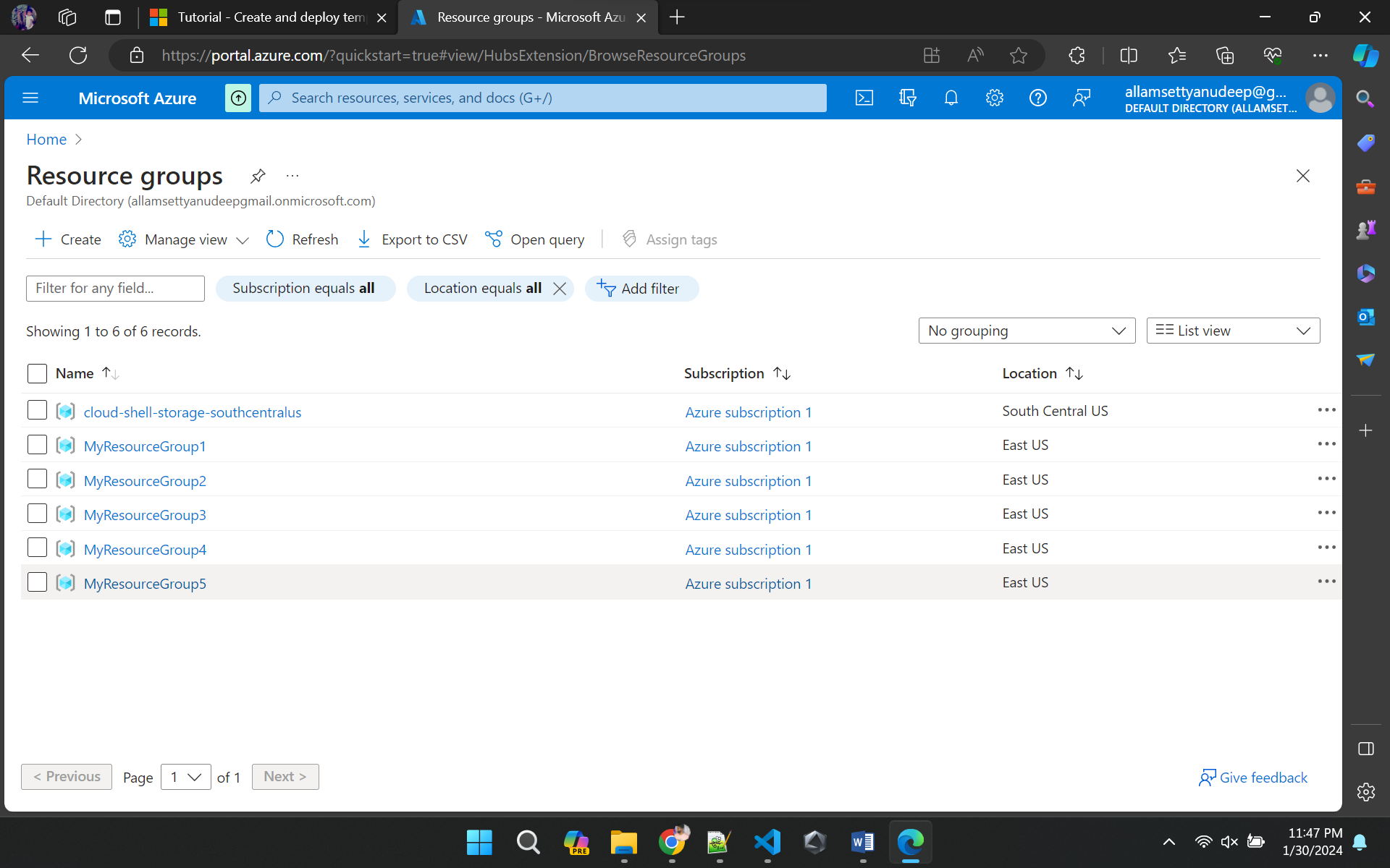

**Create a PowerShell script to provision 5 Resource groups using PowerShell Az commands providing Count and Region during the execution of scripts.**

* Open the Azure Portal and navigate to the Azure Cloud Shell.
* Create a directory using **mkdir <directoryname>** and change directory using **cd <directory name>**
  + **Example: mkdir task3**
  + **Example: cd task3**
* Use **vi** command to create the file (use .sh extension) ,insert (use key ‘i’) and save the script
  + **vi create_resource_groups.ps1**
* To run the script first navigate to the directory then **use ./< .sh file name> <number of resource groups> <location>**
  +** 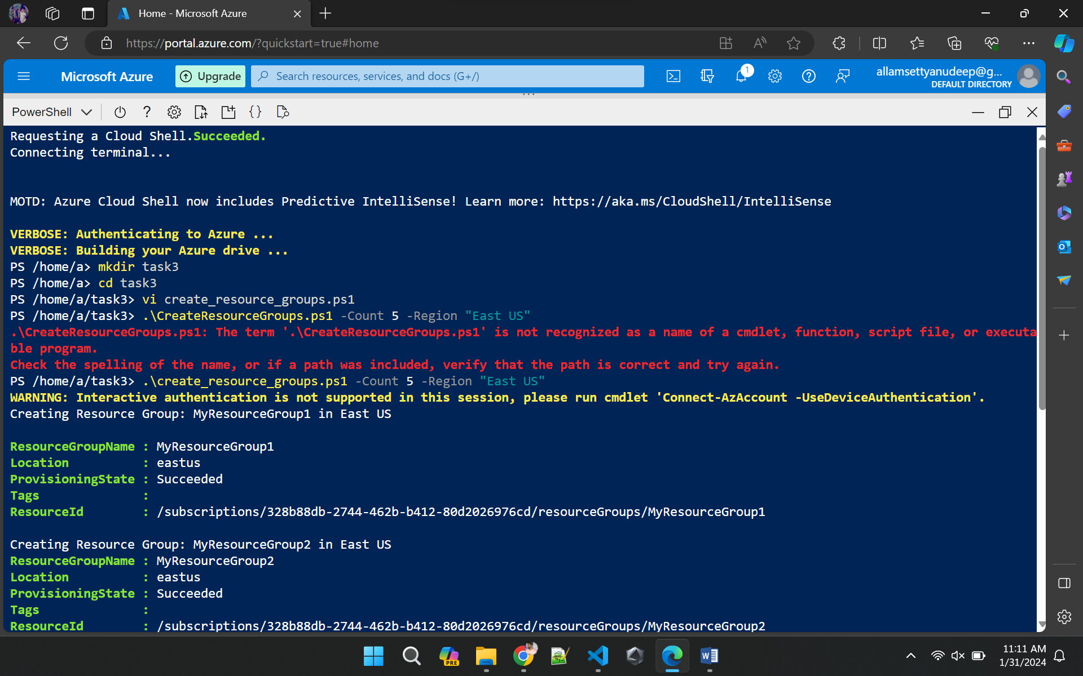./create_resource_groups.sh 5 eastus**

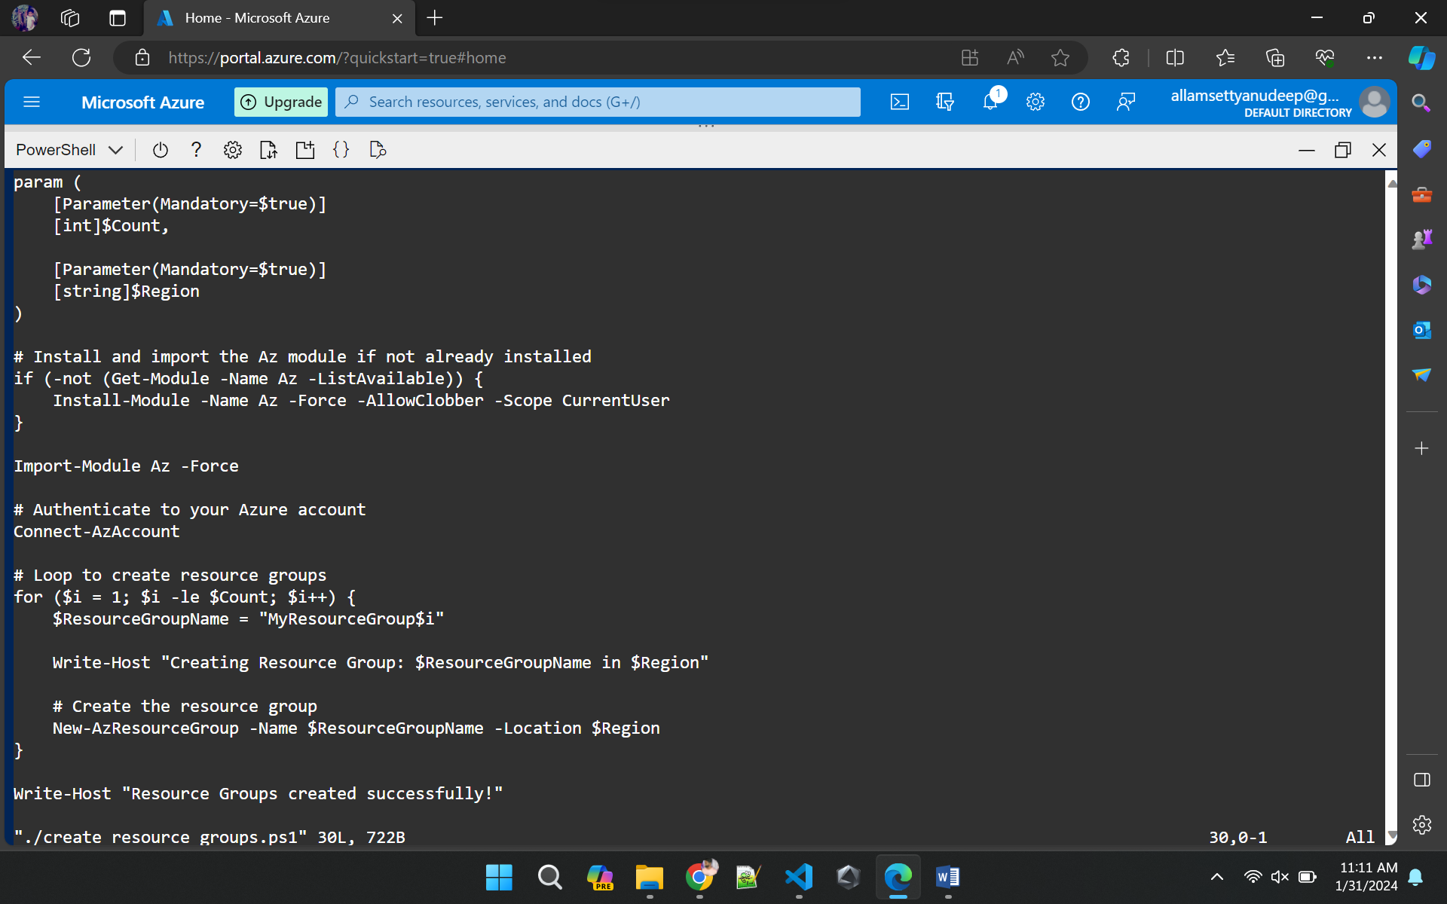

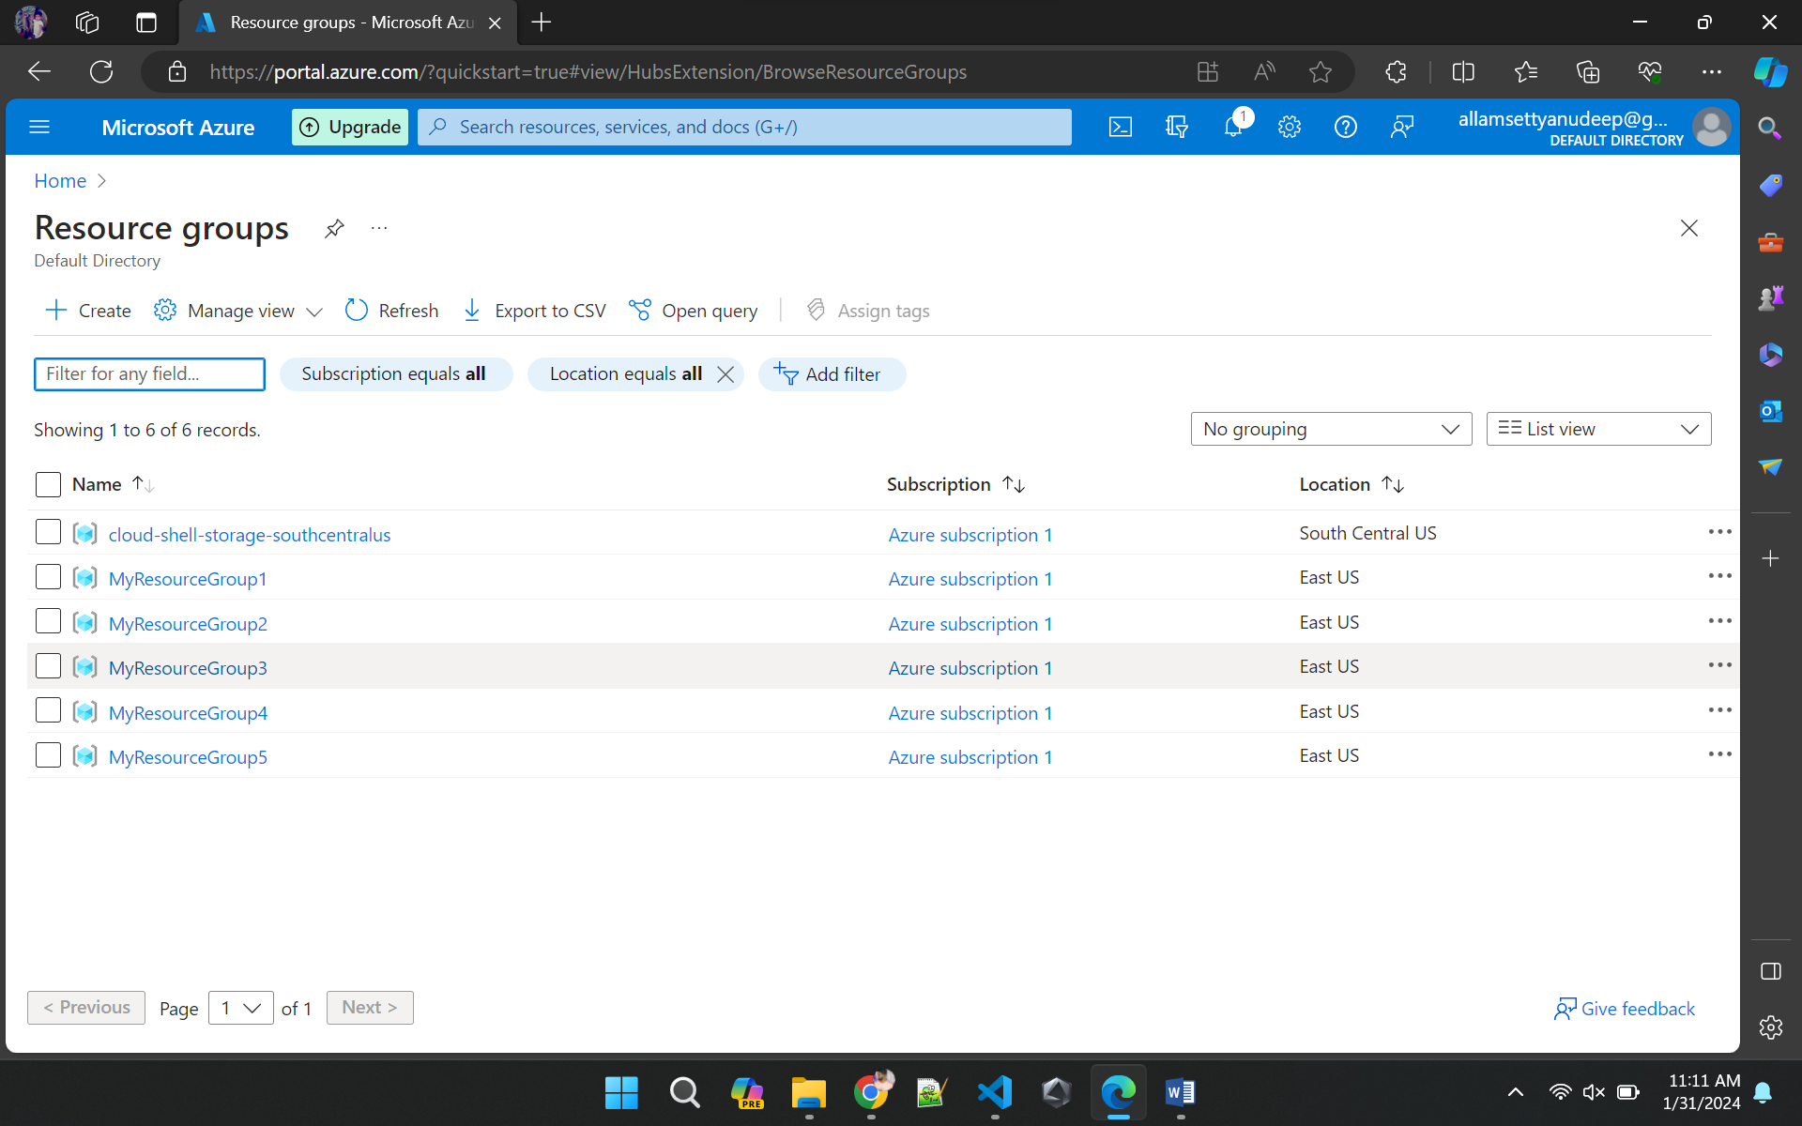

**Deploy blank template to Azure.**

* Open the VS code and create a file an extension of .***json*** and save it (remember the path)
* In the menu bar, click on terminal, a terminal dialogue box appear
* Change the directory to the folder where you save the .json script
* Use **az login** command to login to the azure portal
* To create the resource group, Give the command below which create a resource group with name myResourceGroup

***New-AzResourceGroup `***

***-Name myResourceGroup `***

***-Location "Central US"***

* To deply the template use the resource group you created and use the command below to deploy the template into azure resource group using the azure CLI

***$templateFile = "<path of the .json where you saved>"***

***New-AzResourceGroupDeployment `***

***-Name blanktemplate `***

***-ResourceGroupName myResourceGroup `***

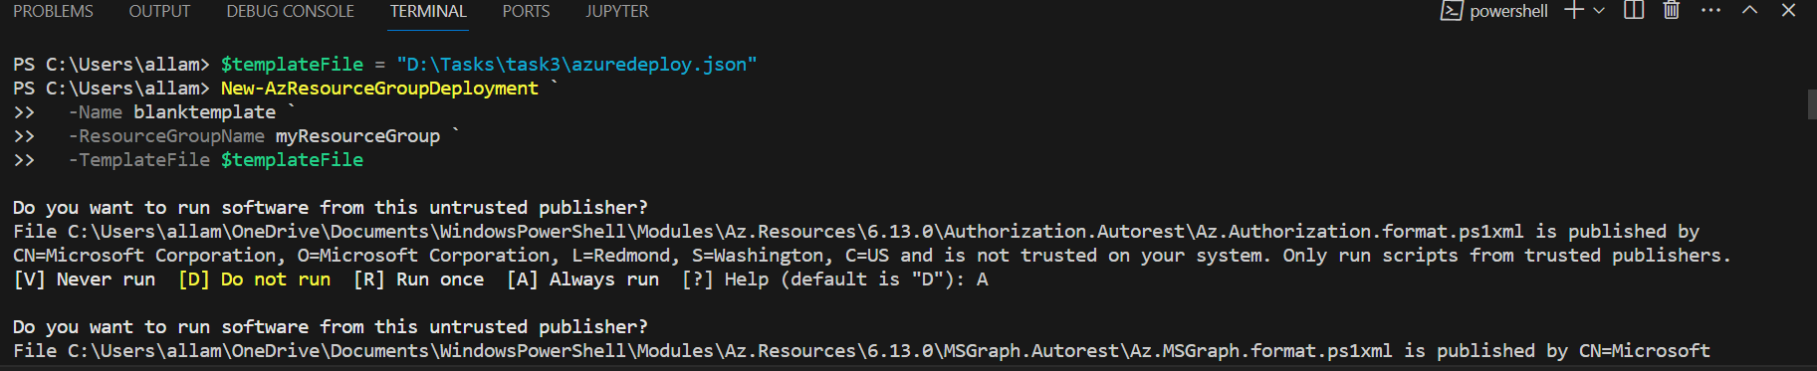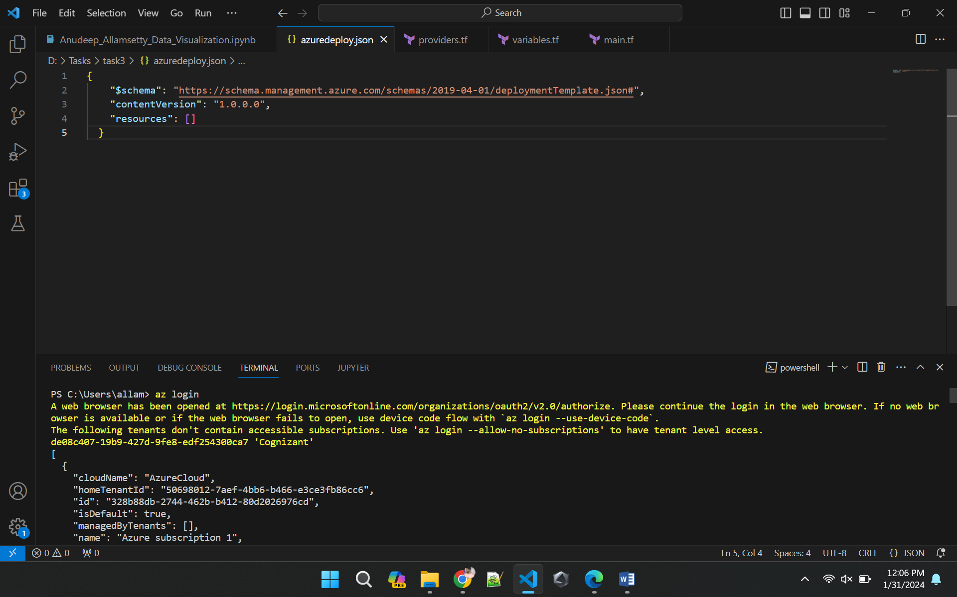 ***-TemplateFile $templateFile***

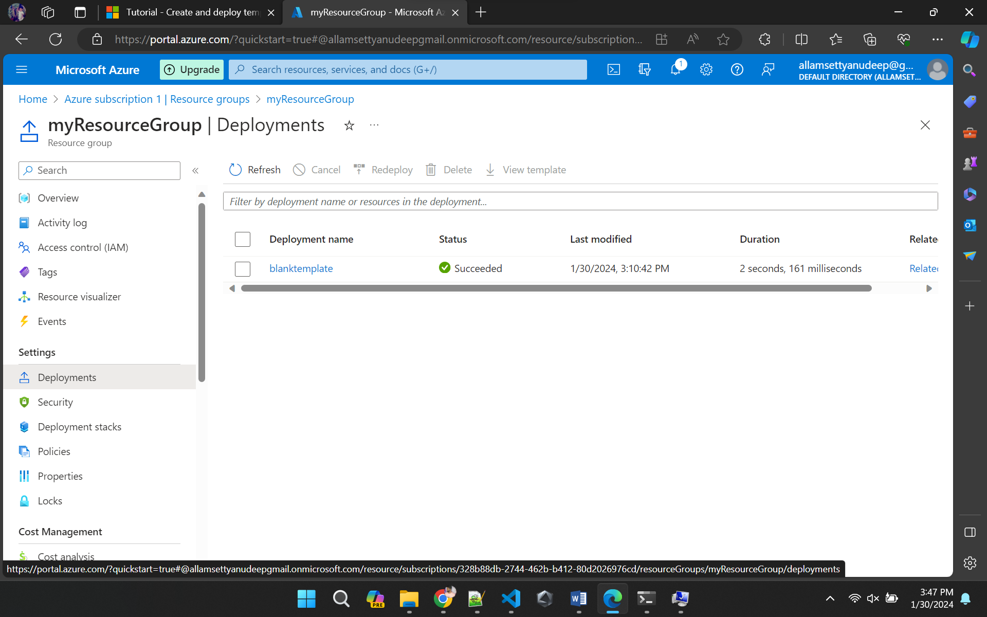

**Provision resource group in Azure through Terraform**

* Open the VS code and create 3 files with extensions **.tf** and name as **providers.tf**, **variables.tf**, **main.tf**
* Save all these scripts in a folder and open the terminal in vs code
* Change the directory to the folder where you save the files
* In the terminal initialize the terraform with the command
  + **terraform init –upgrade**
* **terraform plan** command to visualize the execution plan
* **terraform apply** command to accept and execute to the azure cloud infrastructure

